Miller-Valentine Group Breaks Ground at Lexington County Industrial Park

COLUMBIA, S.C. – January 6, 2009 – Miller-Valentine Group announces the groundbreaking of a new industrial building, Midway Logistics located in the Lexington County Industrial Park.
The 176,400 square-foot multi-tenant building is designed to meet the needs of today’s Class “A” distribution tenants, offering space for lease for industrial tenants from 16,000 SF and up. The tilt-up, hard wall facility will provide a clear height of 28’, energy efficient T-5 lighting, and an ESFR sprinkler system. JanPak, Inc. will anchor the building in a 50,400 square-foot end cap and utilize this building as a distribution hub for the Midlands region.
“Miller-Valentine identified Lexington County Industrial Park as one of the most desirable industrial growth sectors, located at the crossroads of I-26 and I-77. The park provides users with great access to the interstate system as well as an outstanding labor force” said Dale Stigamier, a developer with Miller-Valentine Group. “JanPak is an excellent example of a growth company that recognized the flexibility of this industrial building, as well as the value of its logistical location.”
Miller-Valentine Group has developed and constructed similar industrial projects throughout the Southeast and Midwest, including Carolina Pines I & II, Halle Corporation and most recently, a 150,000 SF spec industrial building in Orangeburg.
For more information about leasing opportunities within the Midway Logistics building at Lexington County Industrial Park, contact Chuck Salley with Colliers Keenan at (803) 254-2300.

# # #

About Miller-Valentine Group

Miller-Valentine Group is a full-service real estate company that offers expert services in the areas of development and construction and has provided total real estate solutions of more than 50 million square feet in a variety of industries. Founded in 1963, Miller-Valentine Group’s commitment to quality, value and service is reflected in its wide range of products, from multi-family residences to Class “A” office and retail developments. Miller-Valentine Group has been awarded the prestigious national “Developer of the Year Award” by NAIOP, a leading association in the real estate industry. For more information regarding Miller-Valentine Group, visit www.mvg.com.

Relevant Photographs
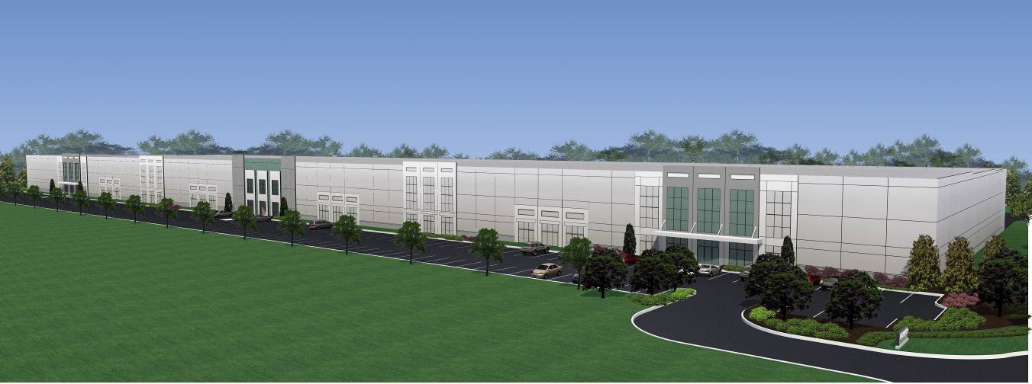

Rendering of Midway Logistics exterior.

